Outline for oral English exam

**Student name**  ________________________________________ **Class**  _______________

**Main topic: The Troubles**

**My topic: Bloody Sunday - The Spark**

**Content:**

The Conflict:

* 1960s - 1990s
* Nationalists vs. Unionists
* Catholic vs. Protestant
* Until the Good Friday Agreement, 10 April 1998

The Spark:

* Northern Ireland Civil Rights Association (1967)
* Battle of the Bogside, 12 to 14 August 1969 (August 1969 riots)
* The British Army, Operation Banner
* The Troubles

Bloody Sunday:

* Sunday 30th January 1972, Londonderry
* 15,000 people
* Protest against internment without trial
* Protest technically illegal
* 1st Battalion, Parachute Regiment
* Fourteen killed

# **Sources:**

*Imperial War Museums*. (2023, jun 21). Retrieved from iwm.org.uk: https://www.iwm.org.uk/history/what-you-need-to-know-about-the-troubles

*nam.ac.uk*. (2023, jun 21). Retrieved from National Army Museum: https://www.nam.ac.uk/explore/troubles-1969-2007

*Why the Troubles started in Northern Ireland*. (2023, jun 21). Retrieved from youtube.com: https://www.youtube.com/watch?v=IHLYeBtGvOg

_____________ __________________________ __________________________

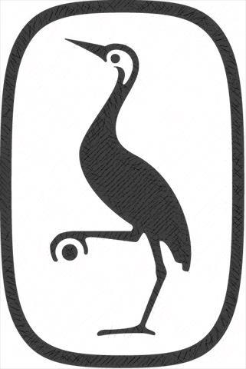

Date Student Teacher

engelsk.gyldendal.dk